|  |  |  |  |  |  |
| --- | --- | --- | --- | --- | --- |
| Date | December 07, 2022 | | | Tester Name | Syed Shahabuddin |
| Environment | Penfax - Test | | | Login used |  |
| Operating System | Windows | Version: | Update: | | |
| Software Used | Edge | Version: | Update: | | |
| Select Software | Version: | Update: | | |
| Release version | 22.4.1 | | | | |
| Title |  | | | | |
| Test Type | Regression | | | | |
| Test Scenario |  | | | | |
|  |  | | | | |
| Expected Results | |  | | --- | | Navigate to Tax Slip Production -> Add Tax Slip Batch | | Create a NR4 tax slip batch for:  - Plan = PEPP  - Report Type = Original  - Tax Year = One year behind | | * Verify that the Tax Slip batch ran successfully | | * Verify that individual NR4 PDFs were created for each member & available on PlaNet | | * Verify that a single XML extract was generated | | * Verify that a single PDF file for all NR4s was generated * Verify tax slip entry is viewable on PENFAX and matches NR4 * Under tax slip, confirm update information & duplicate button works. * Confirm correct tax type and tax percentage was withdrawn (or check test case for non-resident payments to confirm rates) | | | | | |
| Pass/Fail | Pass | | | JIRA# | N/A |

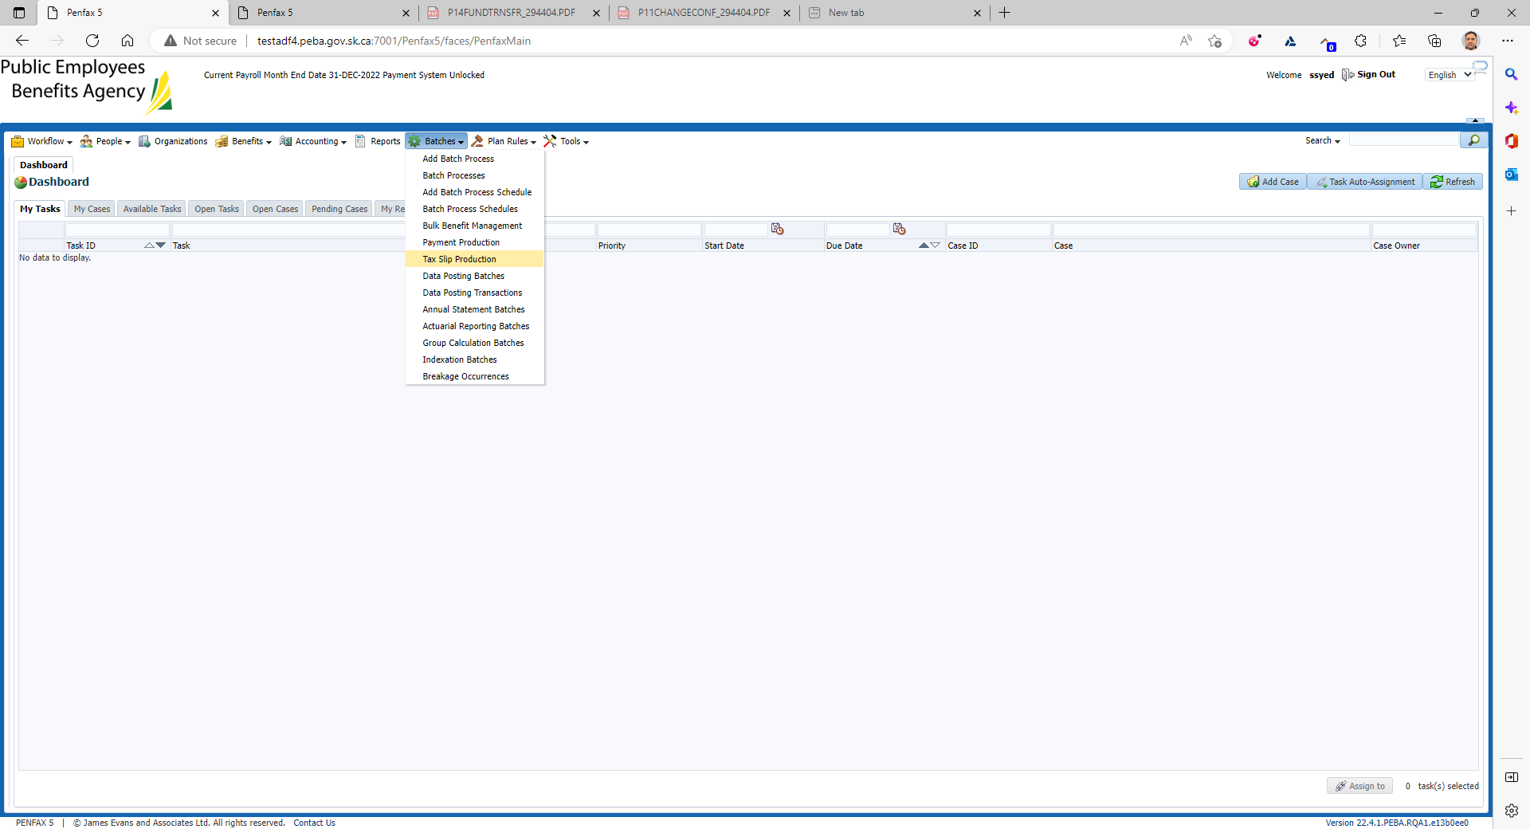

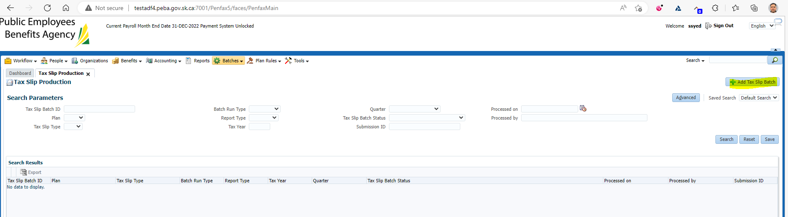

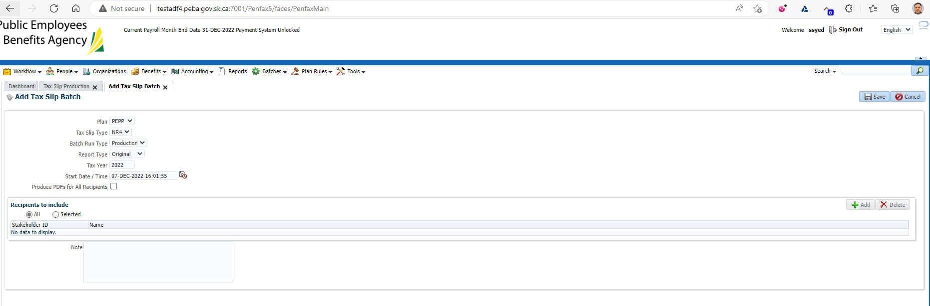

Hit refresh, until the process button is not grey:

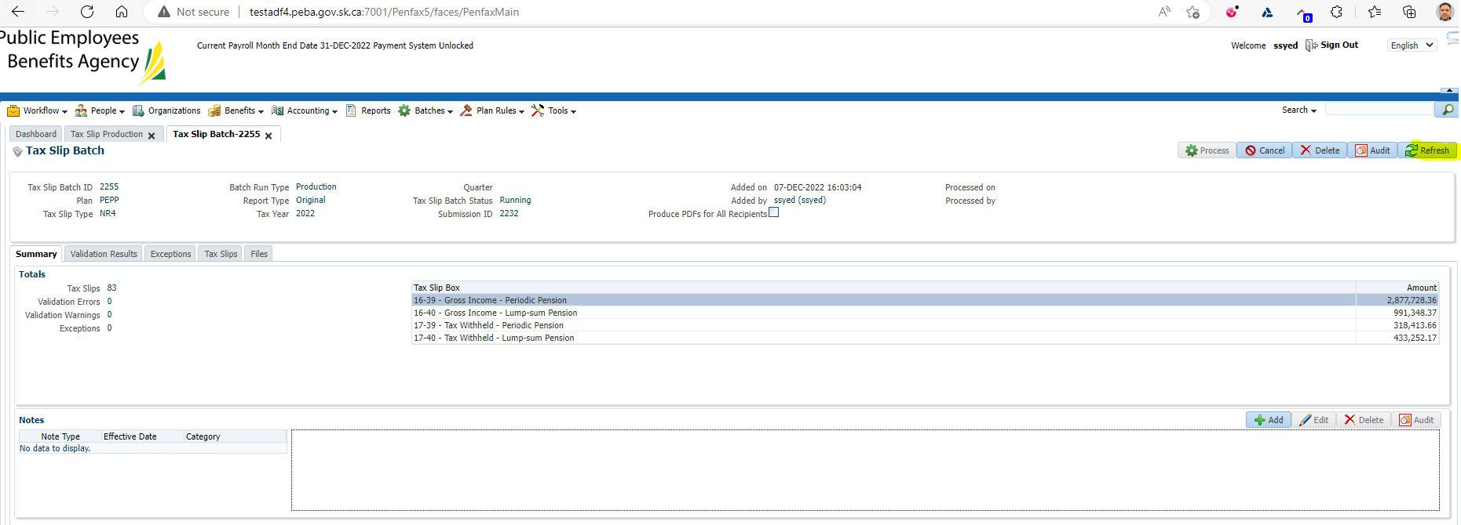

Press process, and yes:

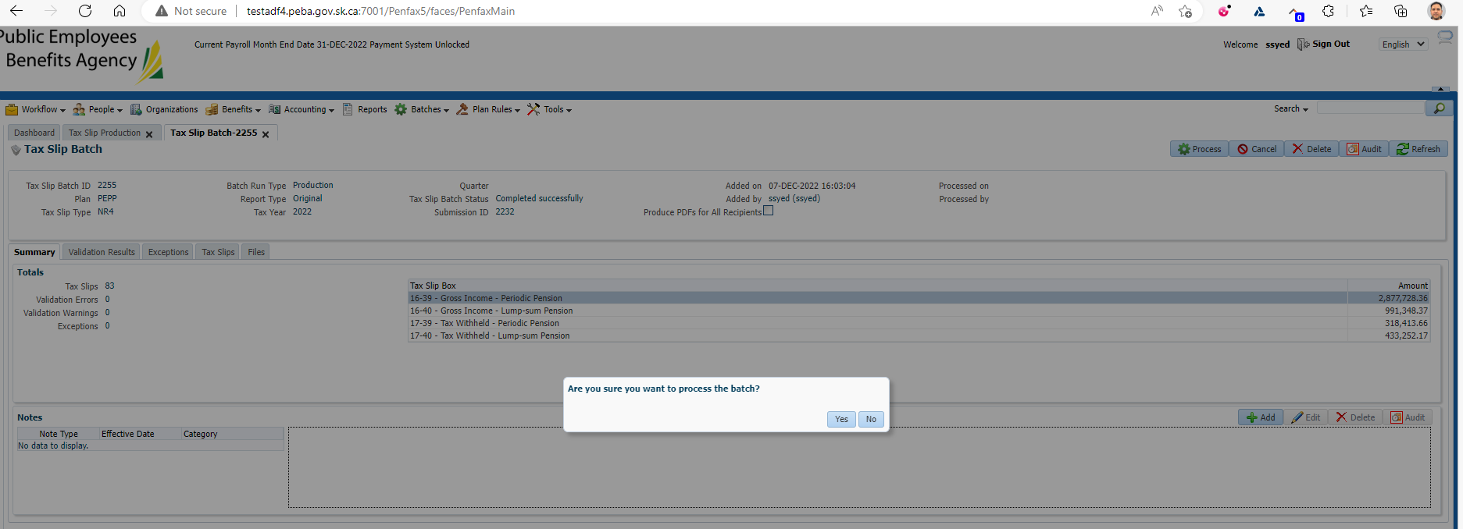

Once completed:

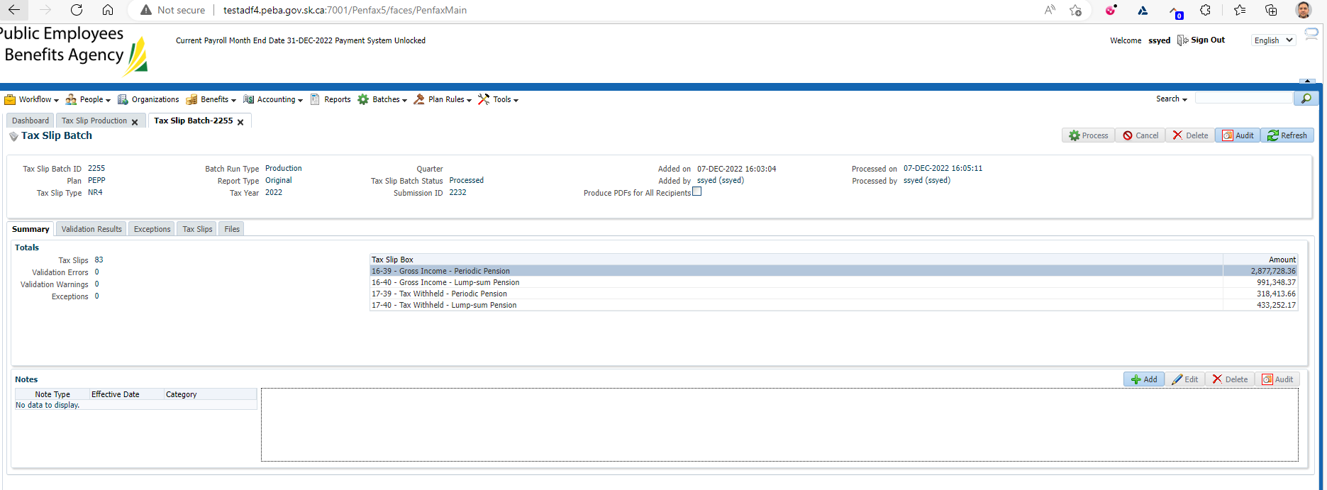

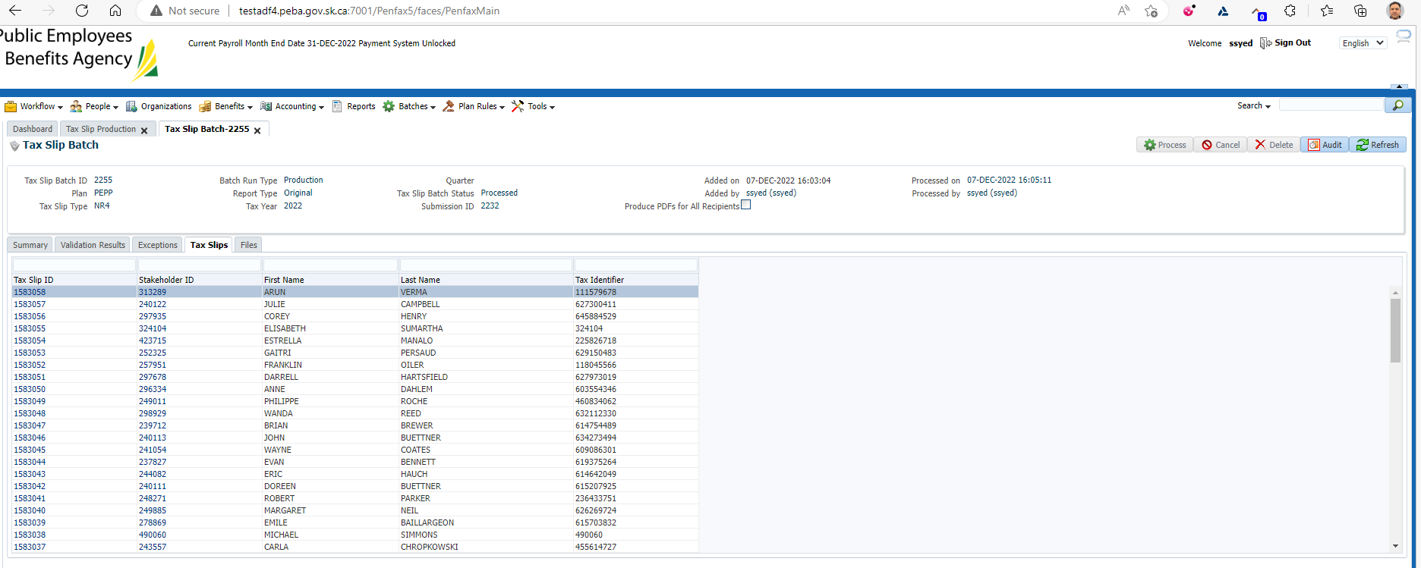

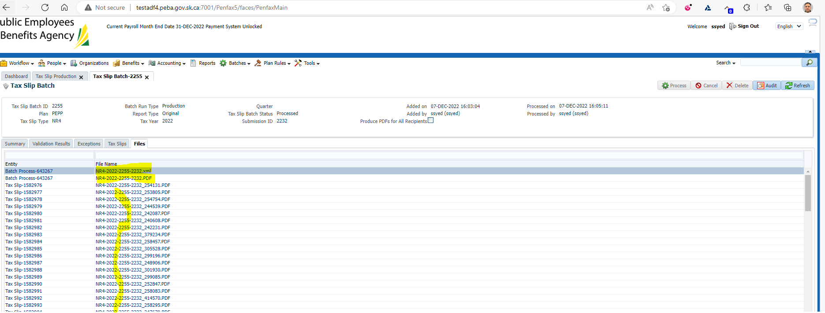

Ensured that the XML file and the large PDF file can save/open:

Made sure that the number of pages makes sense, 83 slips * 2 = 166 pages on PDF.

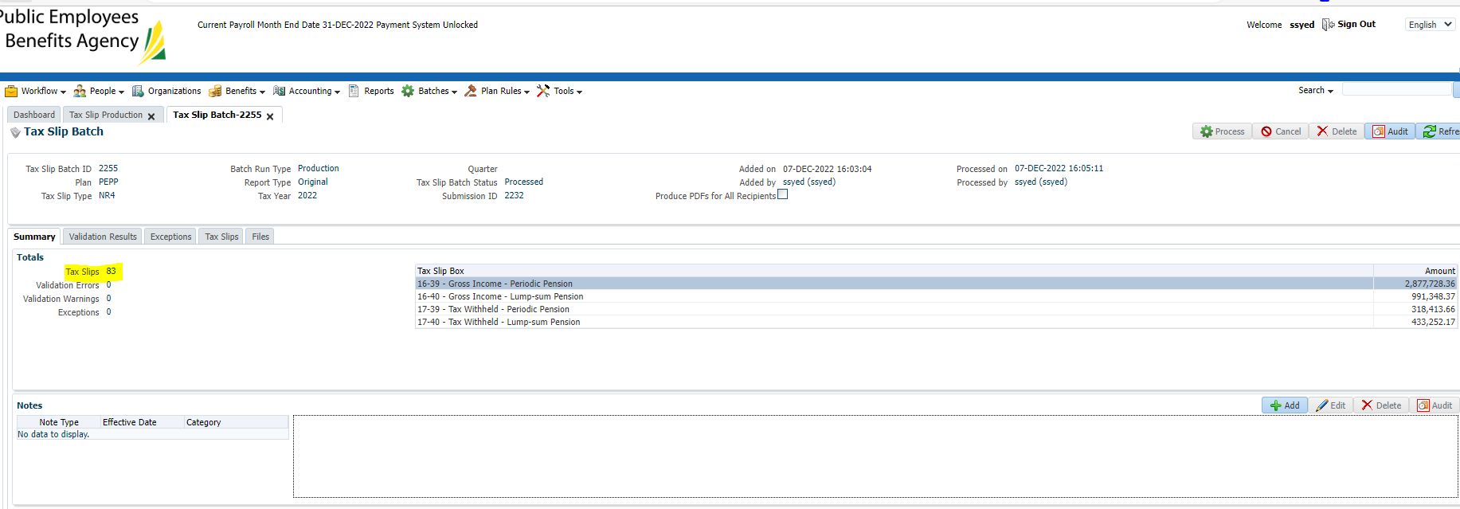

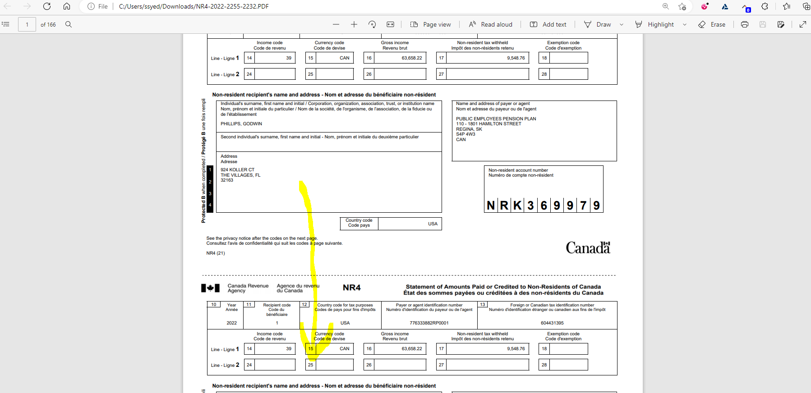

Verify a few members:

**Philips – SID 254131**

2022 NR4:

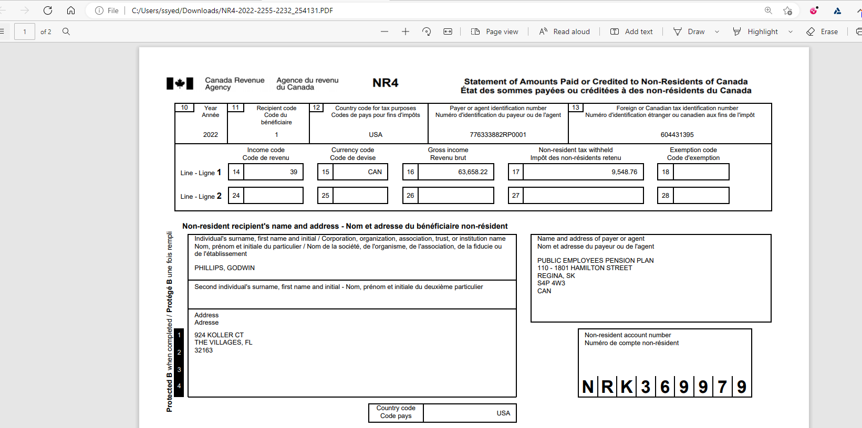

Compare it to 2021 NR4:

Boxes are the same, amounts seem reasonable & populate in a similar format.

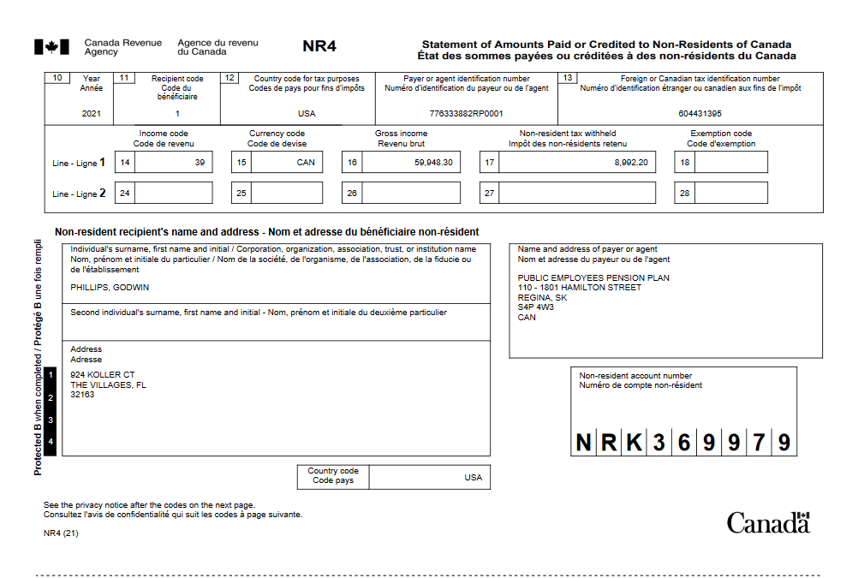

Confirm amounts on 2022 NR4 match withdrawal and tax amounts withdrawn from Penfax:

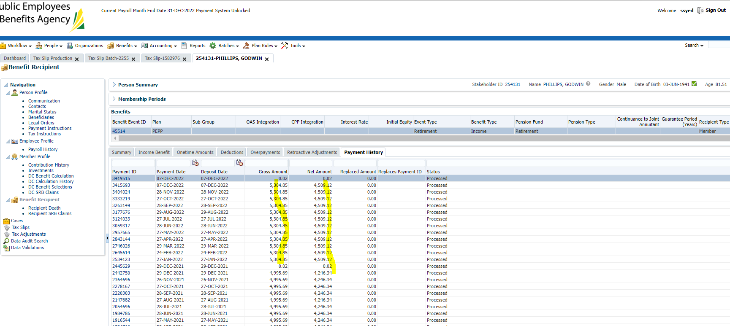

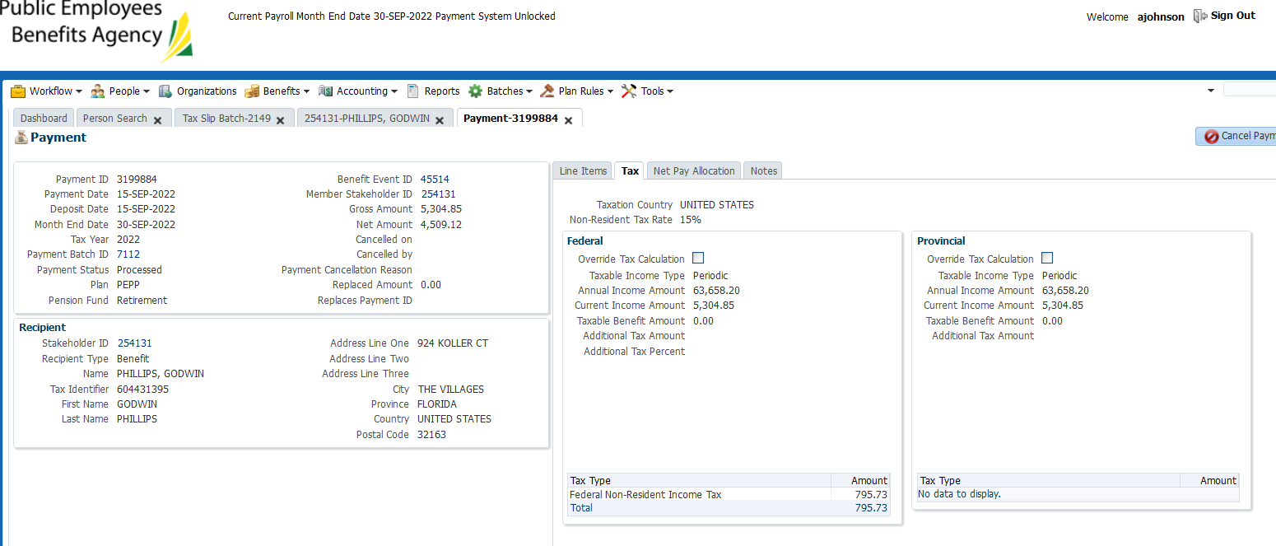

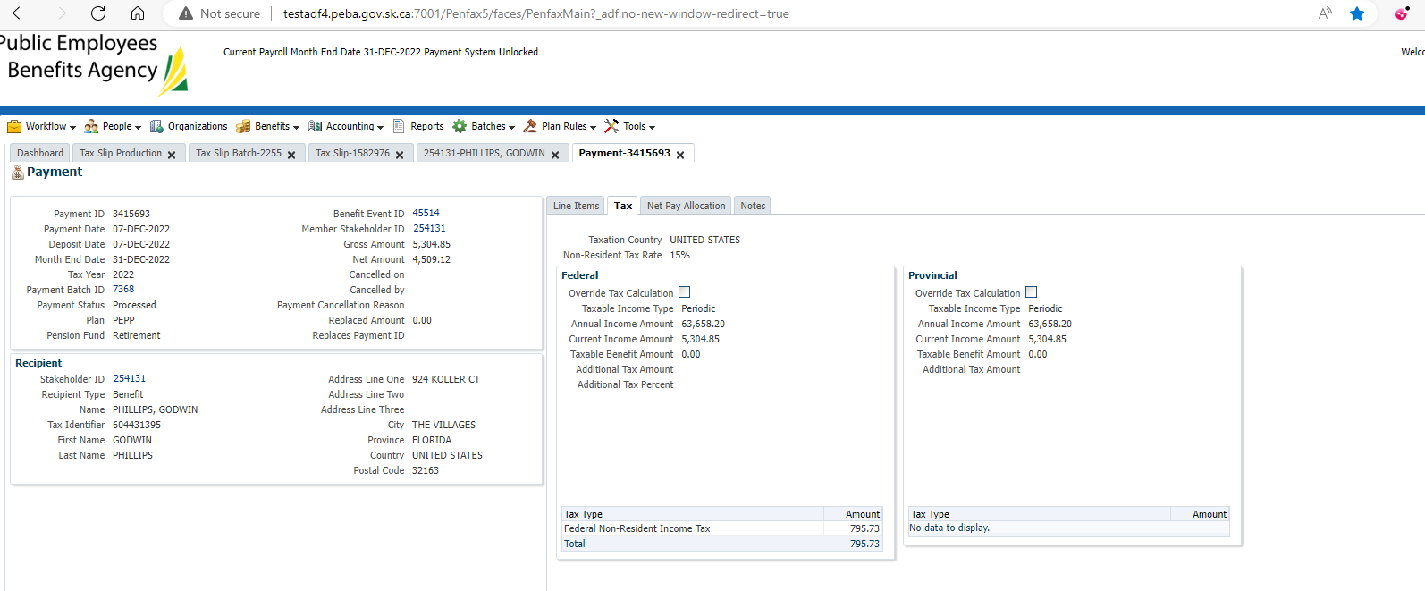

*\*still investigating scheduled withdrawal issue. One is the august payment and one is the extra run performed in September. Ignore the duplicate scheduled withdrawal.*

Total tax withheld: 795.73 * 12 = 9548.76

Total gross payment: 5304.85 * 12 = 63,658.22

Above amounts match the exact amount on the NR4 (should be to the penny). Taxed at 15% - USA period payment rate.

Checked member’s PENWEB, it is visible (incorrect name – should say NR4 – JEA ticket already submitted):

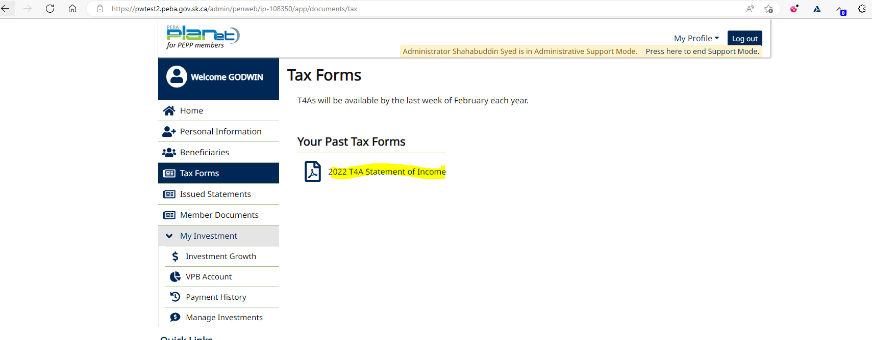

When opened, the correct tax slip is viewed:

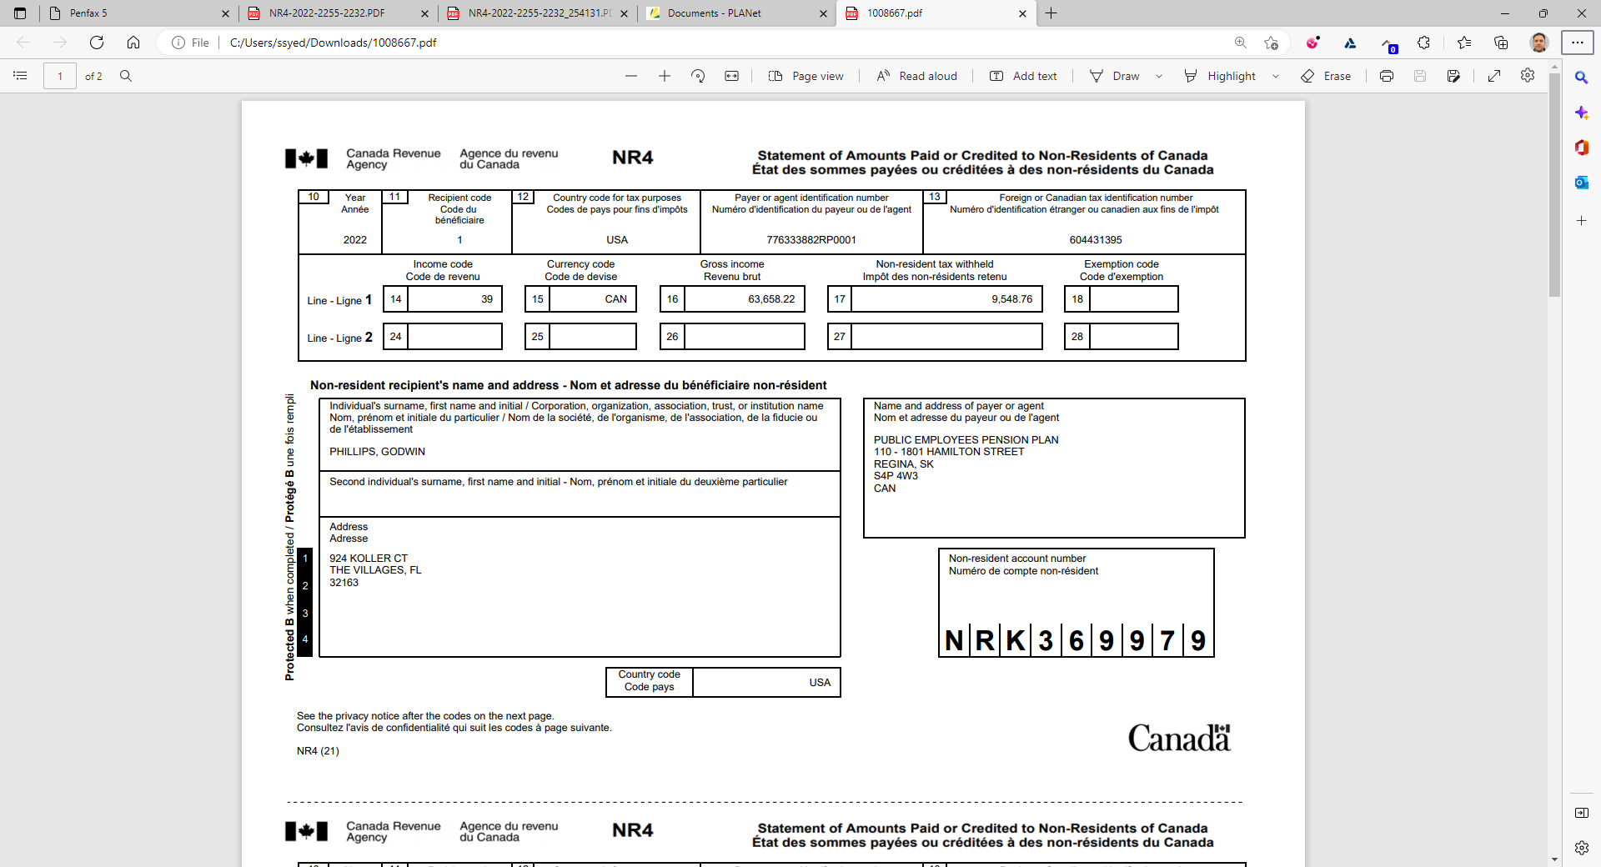

**Capers – SID 380923**

Non PEPP member (Beneficiary upon death of VPB member)

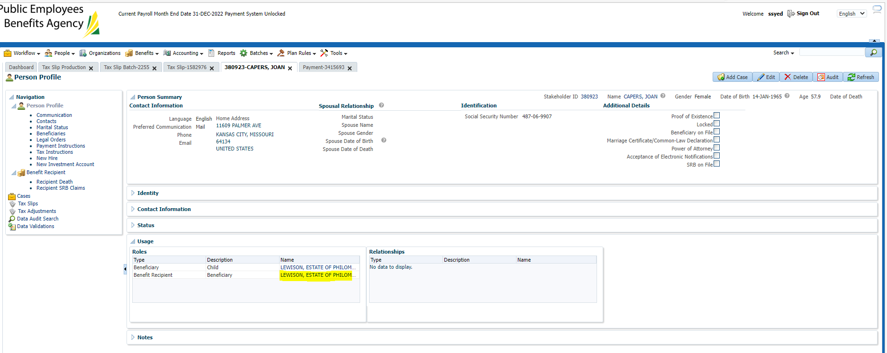

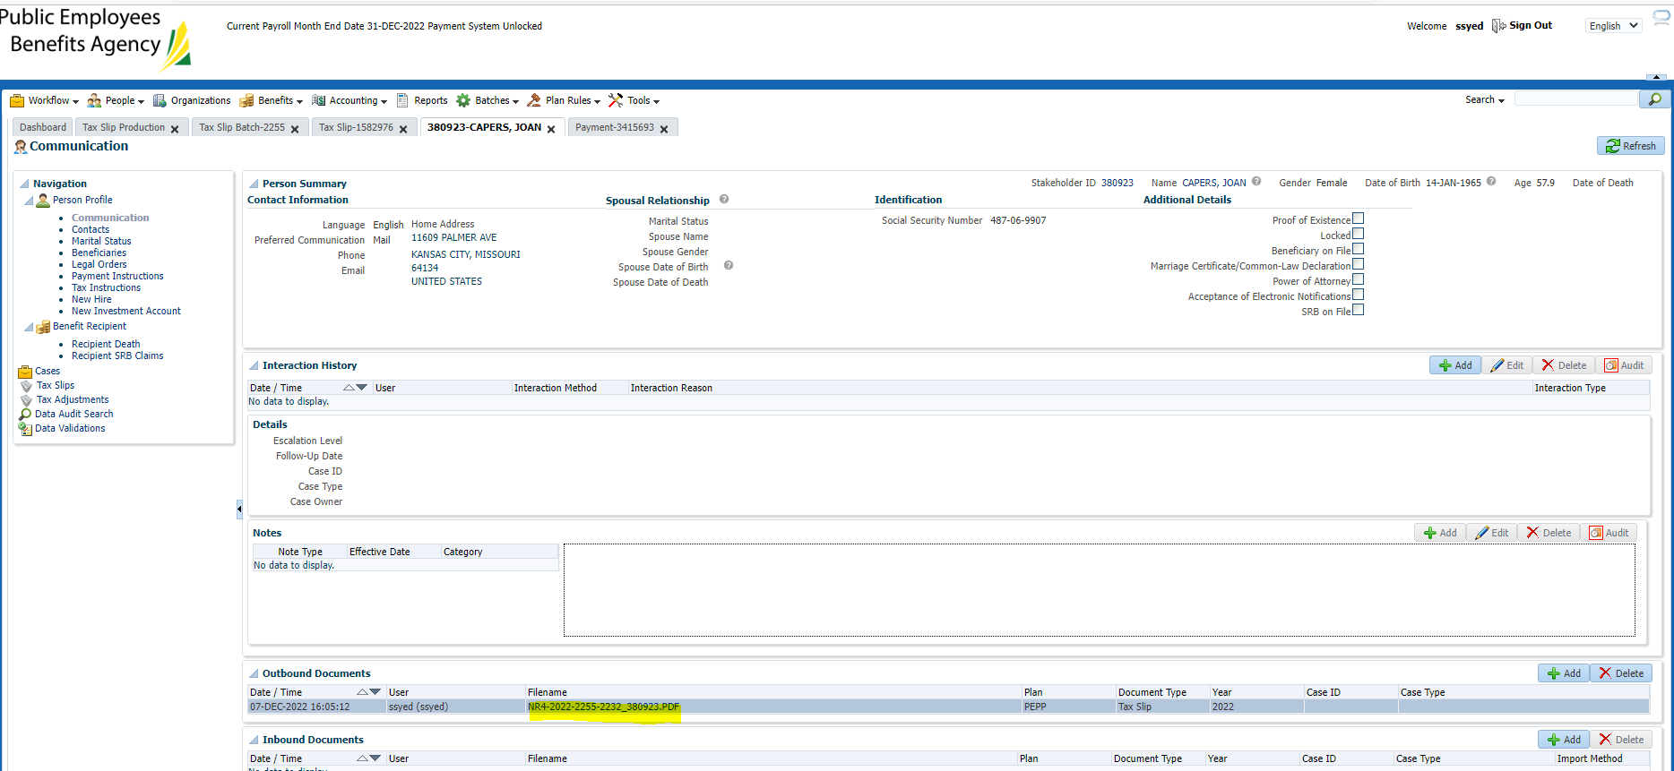

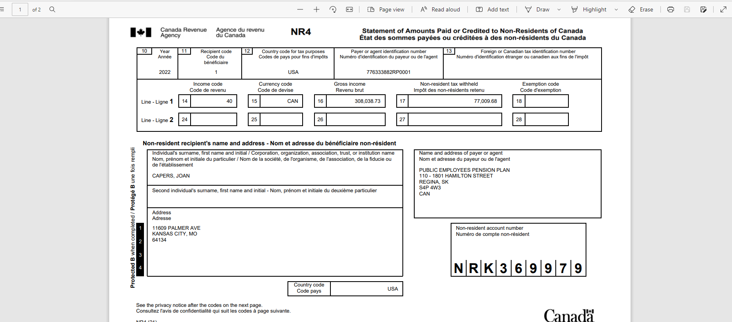

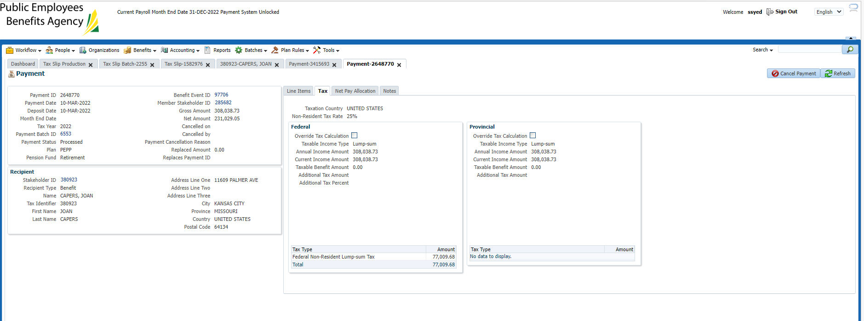

Confirmed address on tax slip matches current address on Penfax.

Confirmed amount of tax withheld, and gross amount is correct.

Confirmed tax type is correct & percentage withdrawn is correct.

Unable to test PENWEB as this isn’t a member thus no account.

Confirmed tax slip was generated in this area & matches PDF:

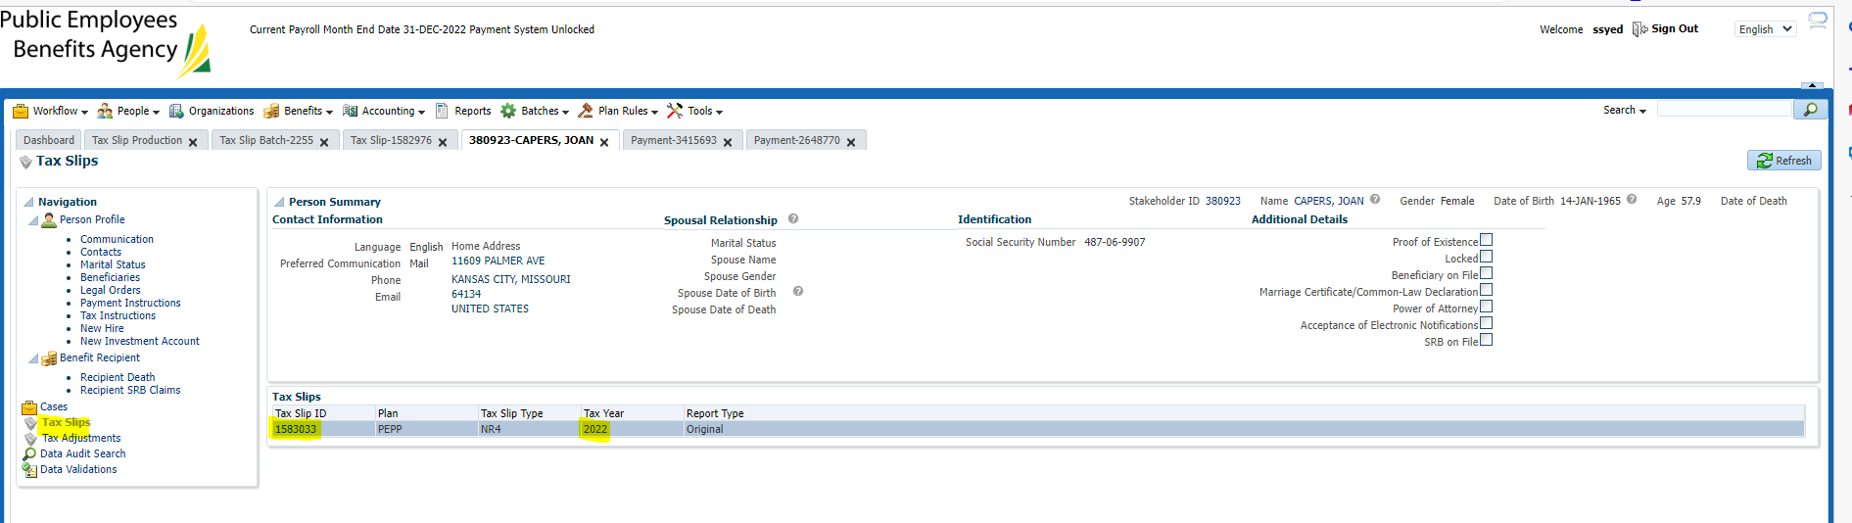

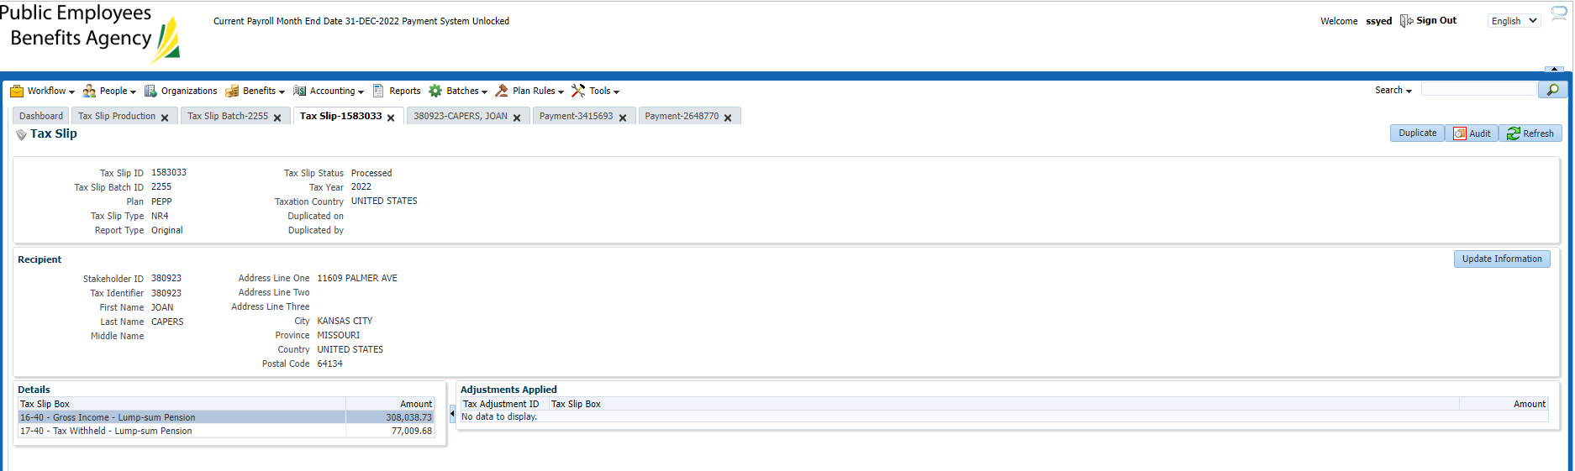

Confirm buttons on tax slip page, update information:

(first update address under person profile).

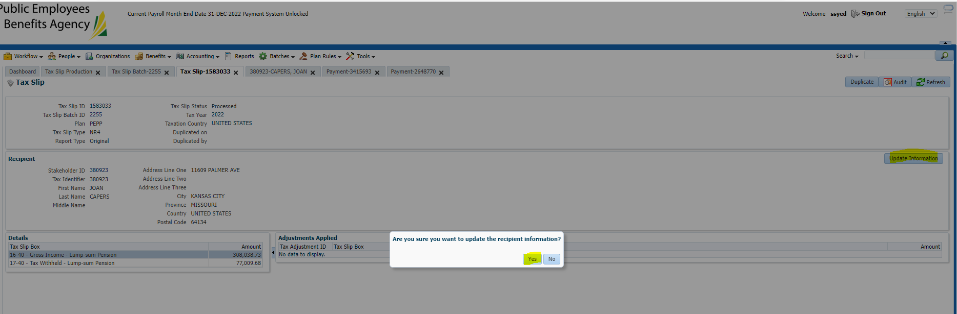

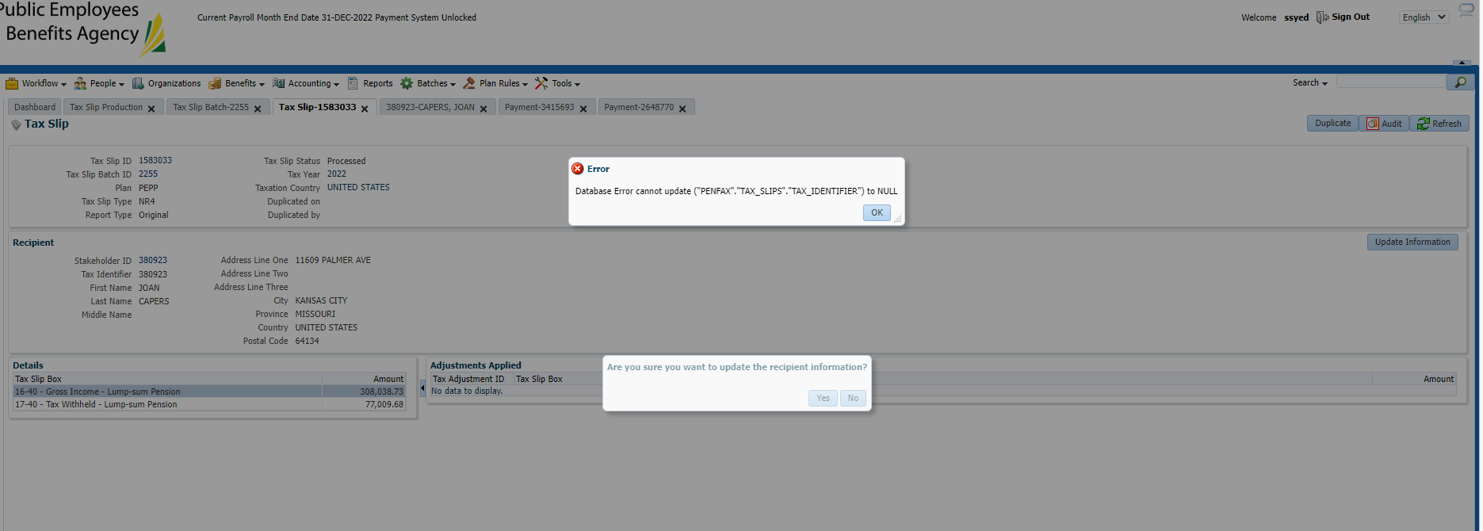

Confirming with Heather if business uses the update information on this page. Confirmed with business and Shanna in taxation that neither use this page. Error Ok’d.